**LAB 1: Metamask Setup**

**Overview**

The purpose of this lab is to help install and configure the Metamask Chrome Extension and create a new Ethereum account which will allow us to send and receive money and also in the future allow us to deploy smart contracts that we create. This lab will also guide you to request ether from Rinkeby test faucet to fund newly created Ethereum account.

**Metamask Background**

Let’s talk about how people like you and me can somehow connect to Ethereum network and make changes to it like say send money or store data or do anything else. In general, there are two different groups of technologies that we need to be aware of for connecting to the network.

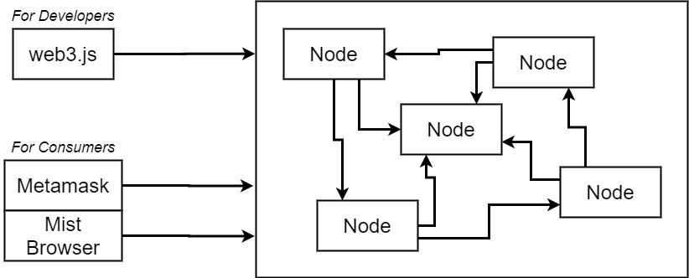

The first is technologies that are used by developers or essentially created for developers like you and me. So, this is going to be technologies that we use to create actual applications that talk to the network through code for that we're going to make use of a library called web 3. You can think of Web 3 as being our sort of portal where our window into the theory and network and it's going to allow us to send money store data deploy contracts or do essentially whatever we want to do on the network.

For consumers there are two great solutions on the market right now. The first is called Metamask. It is a Chrome extension or a browser extension that allows people common people to interact with the Ethereum network. The other is the Mist browser and this is more of a full featured web browser that is intended to be used to browse different theory applications. We're not going to use Mist browser quite so much because it's still in a very early beta and some of its functionality is not quite up to par just yet. But Metamask is a little bit more farther along development and in general it's easier to use. Besides that, I think it's also the most realistic way to expect common people to get on the network right now.

**Installing Metamask Chrome Extension and Creating an Ethereum Account**

Now we're going to install and configure the Metamask Chrome extension. We're going to use this extension to interact with not only the theory of network but it's also going to be used by the different applications that we create as kind of a portal for our users to somehow send money or store data or do whatever else is that we require.

Remember right now you really need to be running Chrome. There's one or two other browsers that work with Metamask but for right now I'm going to show you the directions with chrome.

* Inside of Chrome, Open up a new tab and Click the Apps Icon on the top left of the screen.

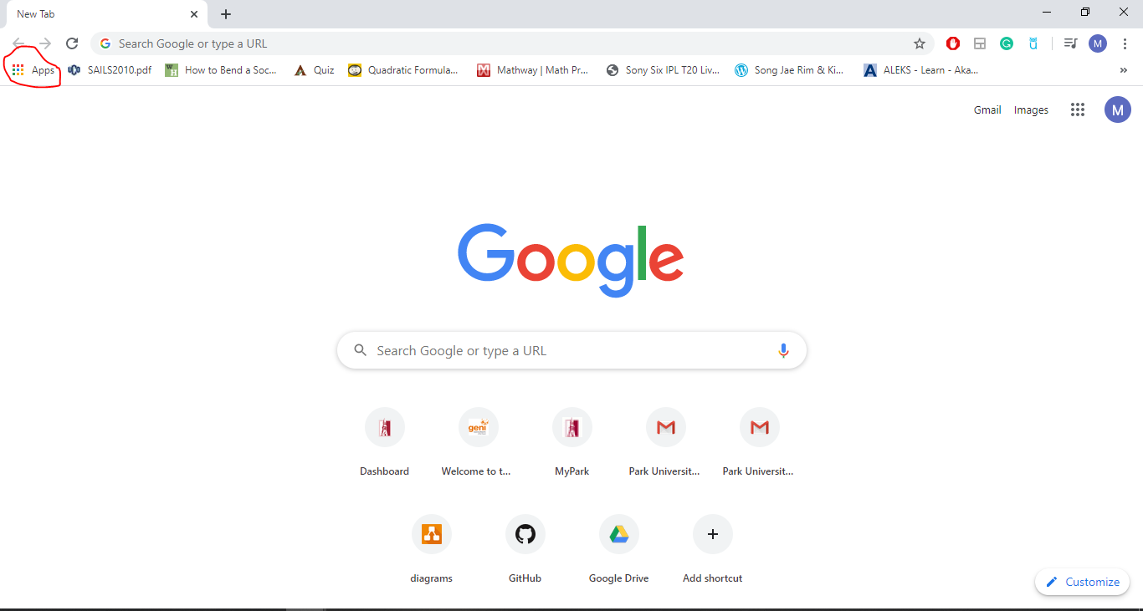

* Find the Web Store and Click it.

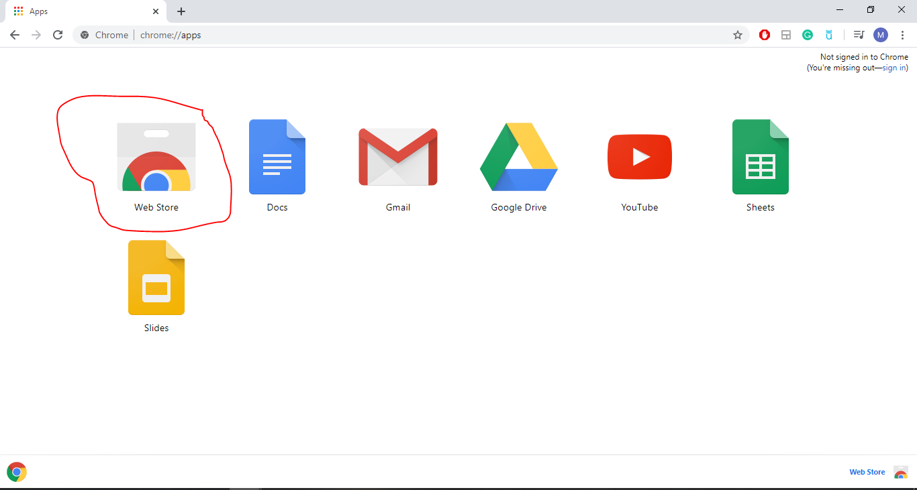

* Search for “Metamask” on search tab within Web Store.

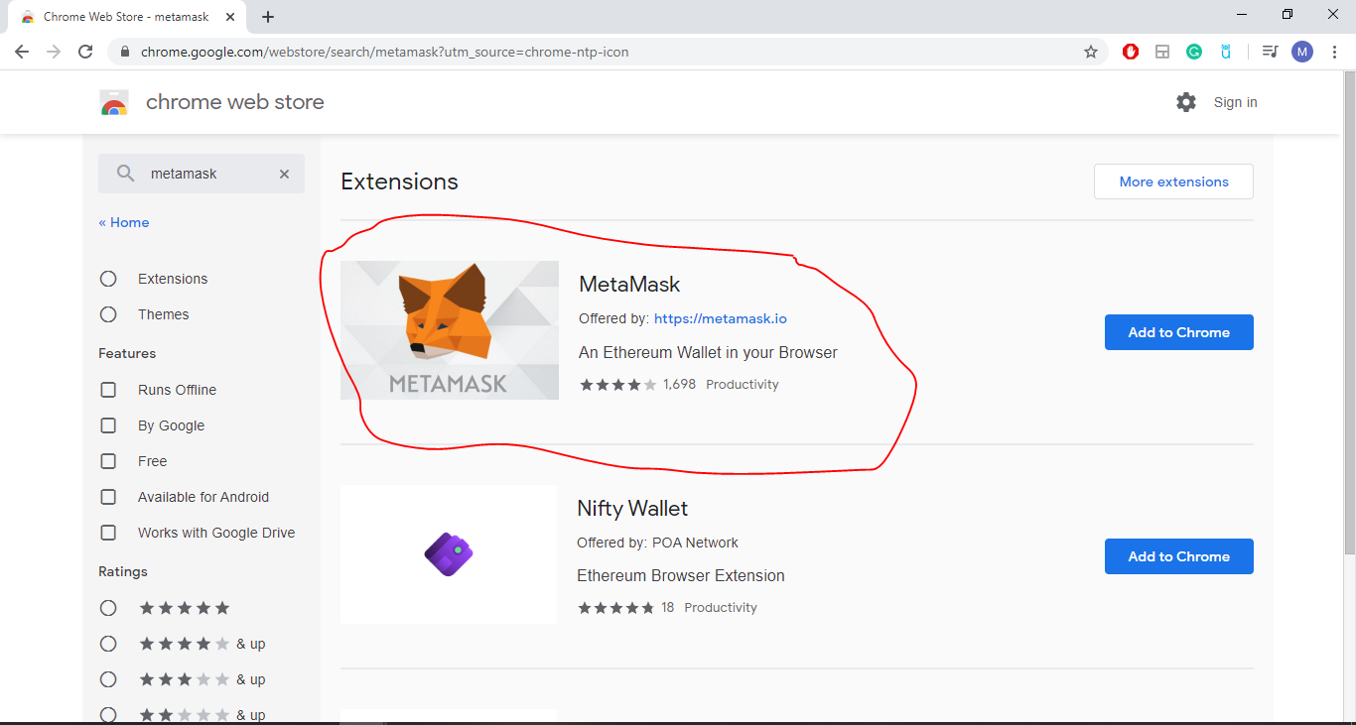

* Recognize it by the little fox icon that they like to use and Click “Add to Chrome” on the right.

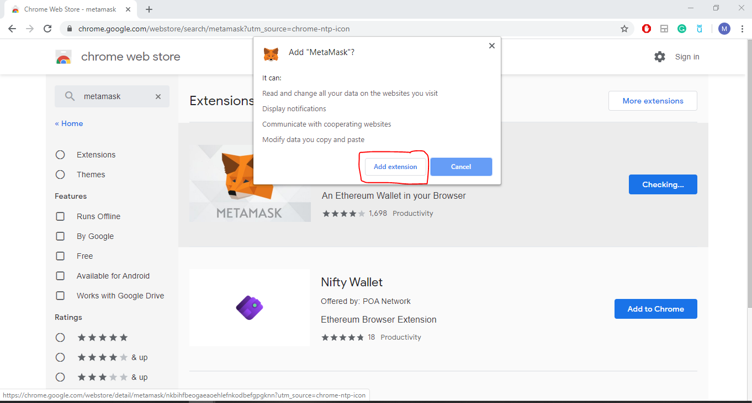

* After the download is completed, it will be automatically added to chrome. You will see the little fox icon on the right side of your screen. Click the icon.

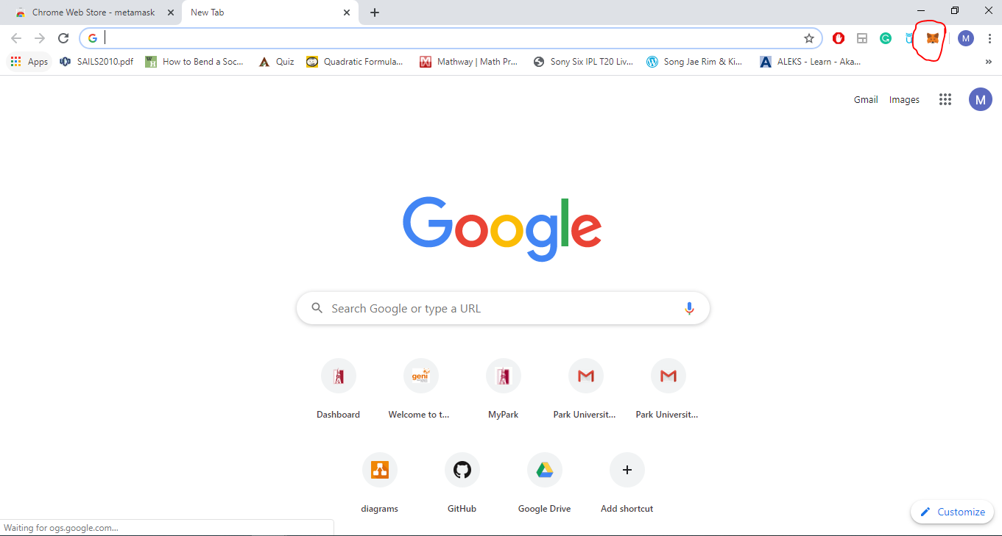

* Click Get Started.

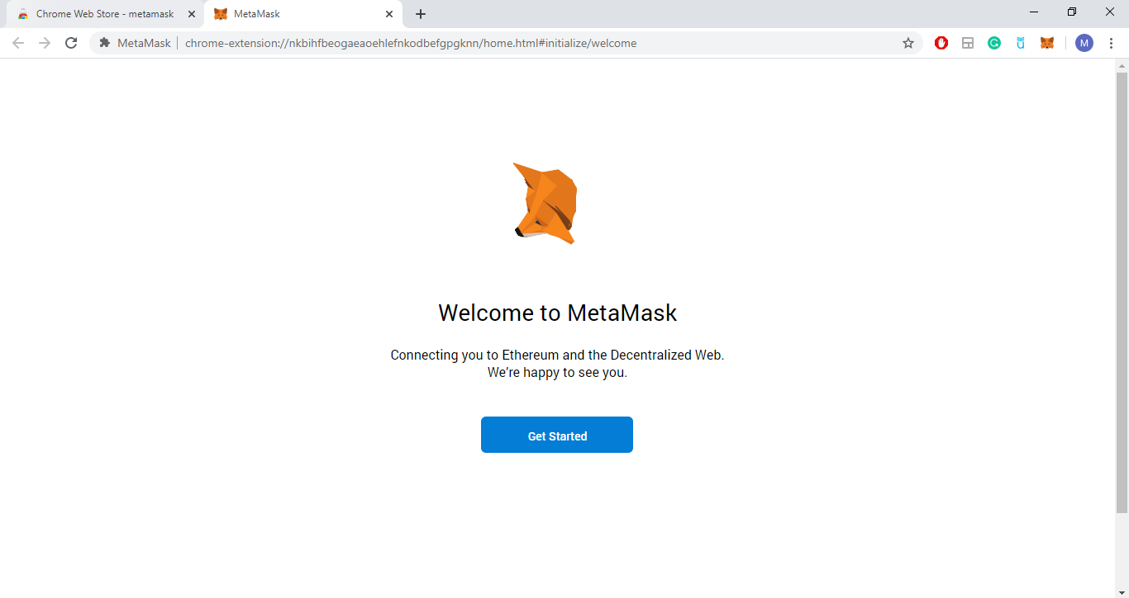

* Choose Create a Wallet option.

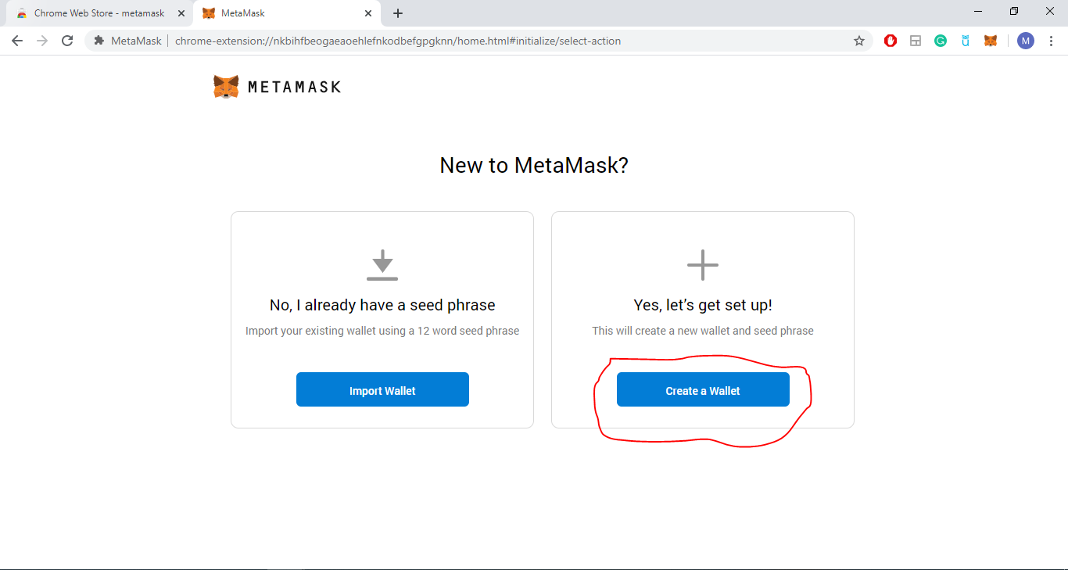

* Click I agree if you agree with the policies.

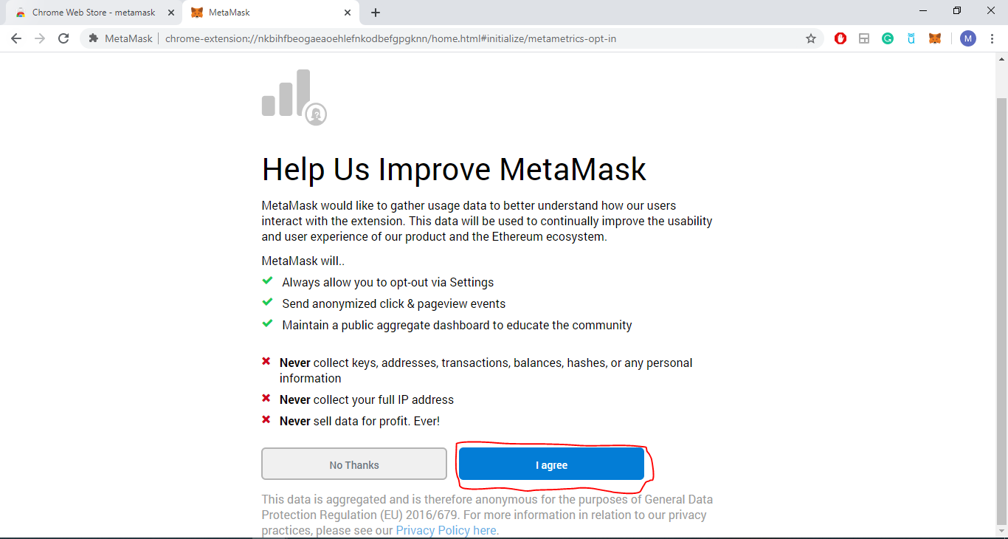

* Create a password for your wallet, agree the terms of use and Click Create Button.

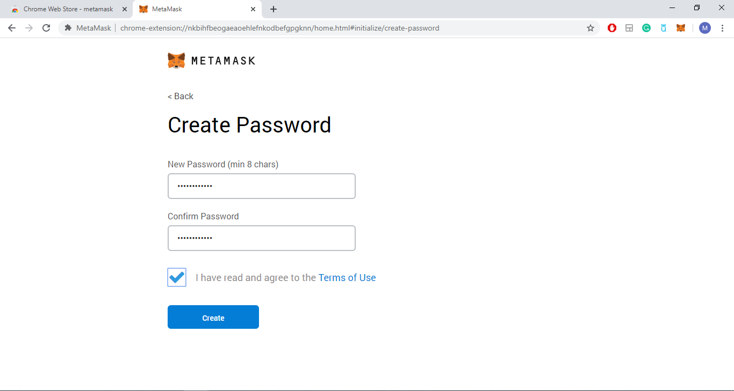

* When you click Create something called a vault is created. So, you will get what is called a new Mnemonic right here. So, these are 12 words that form a new Mnemonic. You need to copy those Mnemonic and keep it safe anywhere because you will need them if you want to use same wallet on another PC or if you ever forget your password.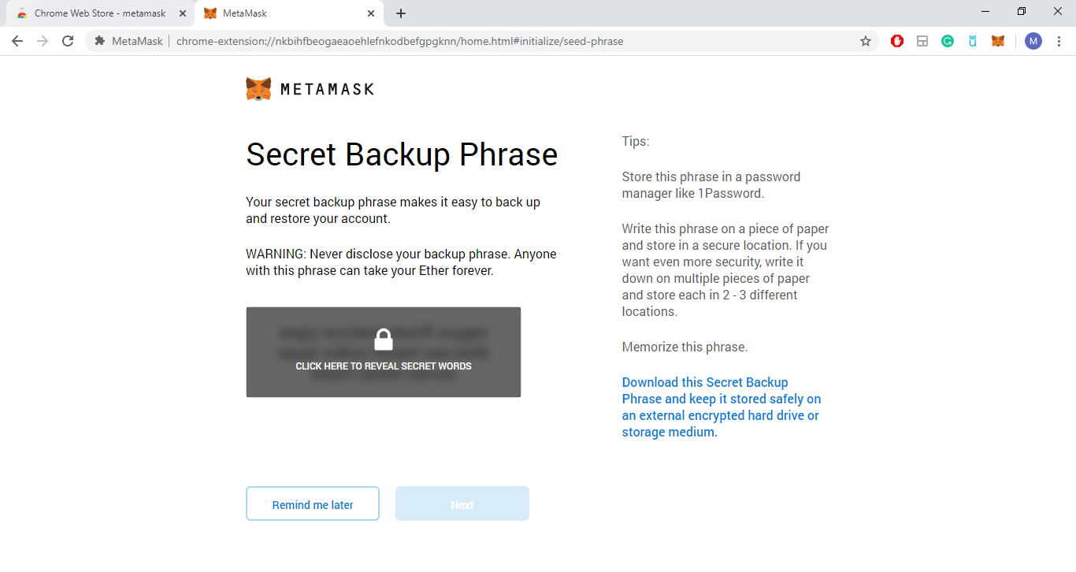

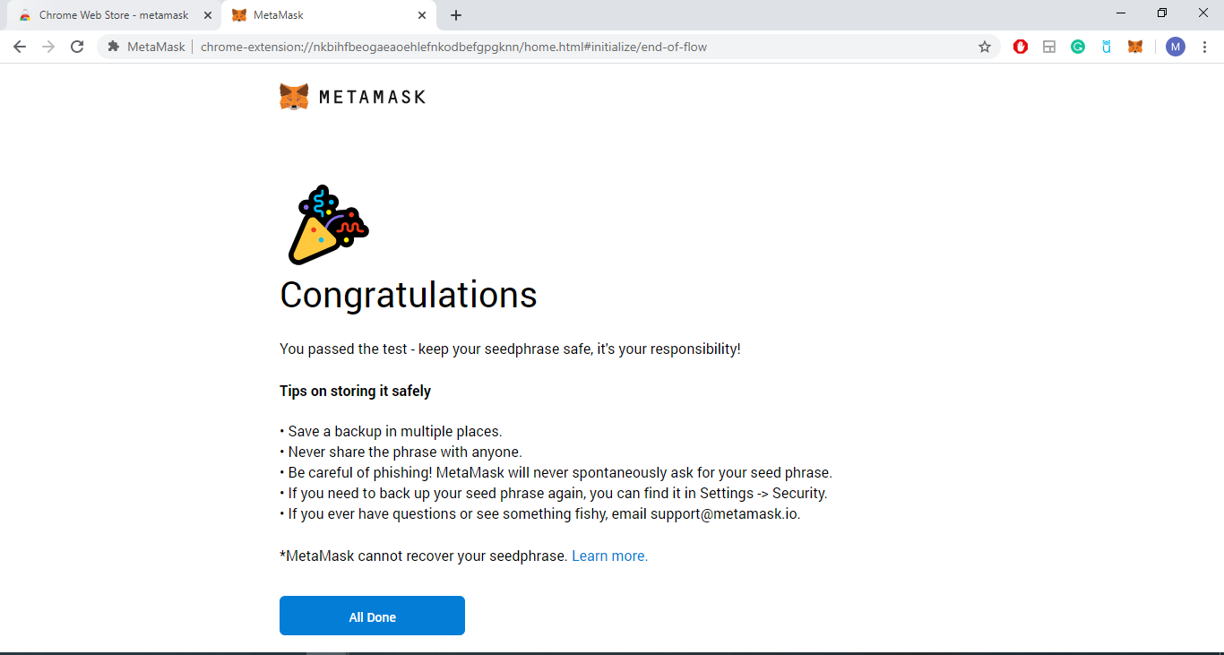

* We just created a new Ethereum account. This account will allow us to send and receive money and it will also in the future allow us to deploy smart contracts that we create. Now, you can just Click to the little fox icon. You will see the screen like below:

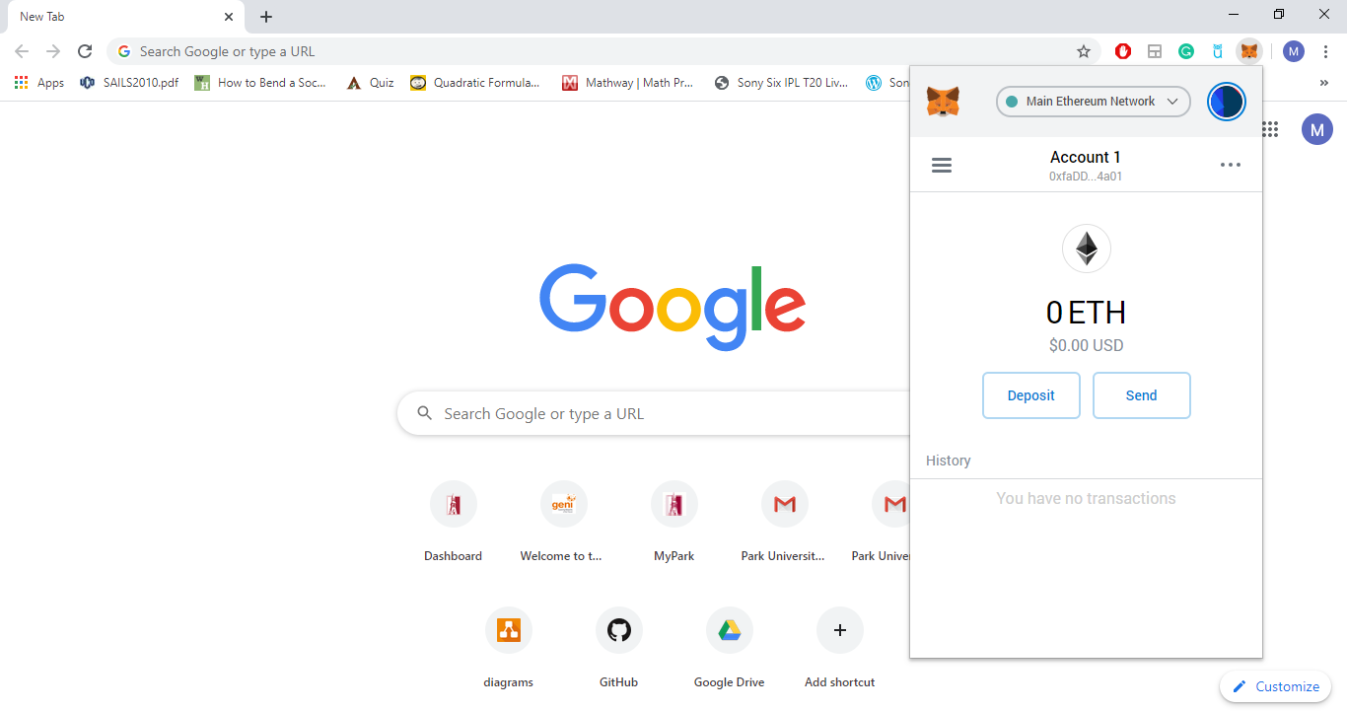

* The first network that is selected by default up here is the main network the main network is the public production network it's where coins are actually worth something and that's where we deploy real applications that we want to use by our users. If we click on this, you can see a dropdown that also shows us several other available networks.

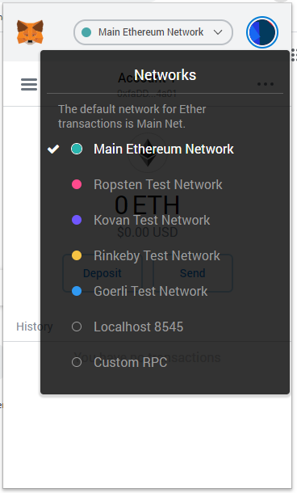

* The three networks underneath Main Ethereum Network i.e. Ropsten, Kovan and Rinkeby are all test networks. These networks are used to test code and to get free ether to test our contracts with we're going to eventually be doing a lot of work with the rink the network down here. So, this is where we are going to be deploying a lot of test contracts that we write, and we'll also use it for a lot of other purposes as well. You can Select Rinkeby Test Network which will be using on this course.

**Funding the Account**

The Rinkeby network has a test faucet (https://faucet.rinkeby.io/) running which we can use to request Ether. However, to request ether from this test faucet, we first need to make a post containing just our Ethereum account address(this is account we want to transfer funds into. We can copy this address by clicking on the ellipses right next to the account name on the Metamask extension) on a social networking site and provide a link to the post to the faucet. It’s pretty straight forward.

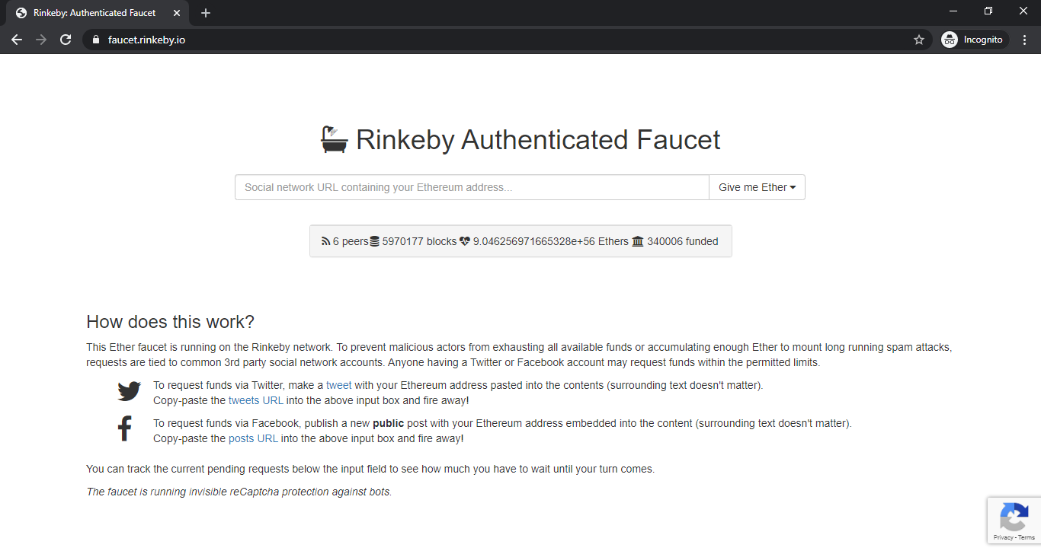

**Metamask Account Details:**

